Caleb Hayden

CIS 310-01

Assignment 9

Due 11/15/17

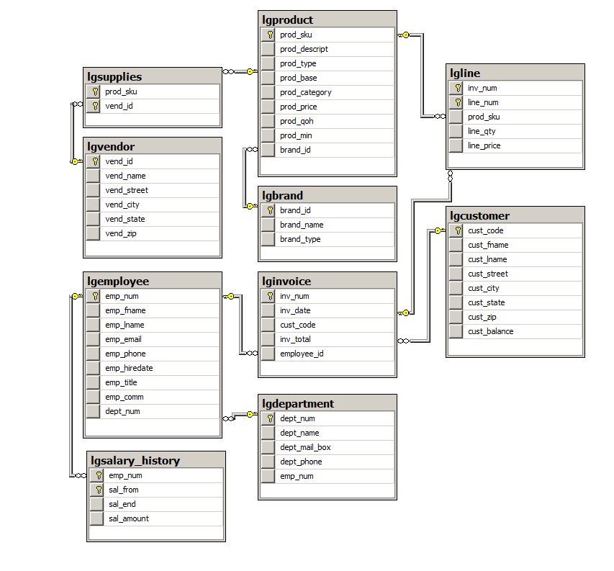

--A9

--Caleb Hayden

--PART 2

CREATE TRIGGER A9

ON LGLINE

AFTER INSERT,DELETE,UPDATE

AS

BEGIN

DECLARE @INV_NUM CHAR(4)

DECLARE @TOTAL NUMERIC(38)

--INSERT

IF(EXISTS(SELECT * FROM INSERTED))

BEGIN

DECLARE INSERTED_CURSOR CURSOR FOR

SELECT INV_NUM,SUM(LINE_QTY*LINE_PRICE) AS TOTAL

FROM INSERTED

GROUP BY INV_NUM

OPEN INSERTED_CURSOR

FETCH NEXT FROM INSERTED_CURSOR

INTO @INV_NUM, @TOTAL

WHILE (@@FETCH_STATUS = 0)

BEGIN

UPDATE LGINVOICE

SET inv_total =INV_TOTAL + @TOTAL

WHERE inv_num = inv_num

FETCH NEXT FROM INSERTED_CURSOR

INTO @INV_NUM, @TOTAL

END

CLOSE INSERTED_CURSOR

DEALLOCATE INSERTED_CURSOR

END

--DELETE

ELSE IF(EXISTS(SELECT * FROM DELETED) AND NOT EXISTS

(SELECT * FROM INSERTED))

BEGIN

DECLARE DELETED_CURSOR CURSOR FOR

SELECT INV_NUM, SUM(LINE_PRICE) AS TOTAL

from DELETED

GROUP BY INV_NUM

OPEN DELETED_CURSOR

FETCH NEXT FROM DELETED_CURSOR

INTO @inv_num, @TOTAL

WHILE (@@FETCH_STATUS = 0)

BEGIN

UPDATE LGINVOICE

SET inv_total = INV_TOTAL + @TOTAL

WHERE inv_num = inv_num

FETCH NEXT FROM DELETED_CURSOR

INTO @INV_NUM, @TOTAL

END

CLOSE DELETED_CURSOR

DEALLOCATE DELETED_CURSOR

END

--UPDATE

ELSE IF(EXISTS(SELECT * FROM INSERTED) AND EXISTS (SELECT * FROM DELETED))

BEGIN

DECLARE UPDATED_CURSOR CURSOR FOR

SELECT I.INV_NUM, SUM(I.LINE_QTY*I.LINE_PRICE) - (D.LINE_QTY * D.LINE_PRICE) AS TOTAL

FROM DELETED D INNER JOIN INSERTED I ON D.INV_NUM = I.INV_NUM

WHILE (@@FETCH_STATUS = 0)

BEGIN

UPDATE LGINVOICE

SET INV_TOTAL = INV_TOTAL + @TOTAL

WHERE INV_NUM = INV_NUM

FETCH NEXT UPDATED_CURSOR INTO @INV_NUM, @TOTAL

END

CLOSE UPDATED_CURSOR

DEALLOCATE UPDATED_CURSOR

END

END

--PART 3

Select *

From LGINVOICE

Select *

From LGINVOICE

WHERE INV_NUM IN (110,111,112,113,114)

--create temp table

Select * INTO TEMPORARY

FROM LGINVOICE

WHERE INV_NUM IN (110,111,112,113,114)

--insert

INSERT INTO LGLINE

SELECT *

FROM TEMPORARY

--delete

DELETE

FROM LGLINE

WHERE INV_NUM IN (110,111,112,113,114)

--update

UPDATE LGLINE

SET LINE_QTY = LINE_QTY + 4

WHERE INV_NUM IN (110,111,112,113,114)